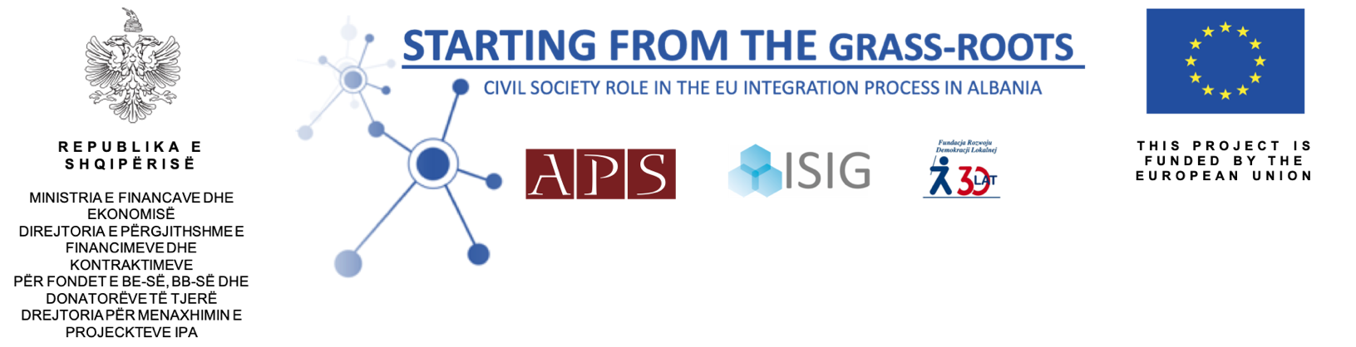

^{Terms of Reference}
  - Expert: Research and study on Albania's path towards EU

The Academy of Political Studies is looking for an expert for preparing a Research and study on Albania's path towards EU, in the framework of the project “Starting from the grass-roots: Civil society Role in the EU Integration Process in Albania”, under the lot EuropeAid/138384/ID/ACT/AL “Support to Civil Society Organizations for the Implementation of Capacity Building Actions to Increase Policy Dialogue and Awareness on European Integration Process”, funded under the European instrument IPA II European Union Integration Facility 2014.

Interested and qualified candidates should send their application, not later than 5 February 2020, at info@asp.al indicating the subject heading "Expert for preparing a Research and study on Albania's path towards EU”, or at the Academy of Political Studies Office: Kotoni Center, Rr.Donika Kastrioti, Nr.3, Kati 2, Zyra 5, Tirana, Albania.

The Academy of Political Studies (APS) is a non-for-profit organization, established in October 2009, with the purpose to foster a modern political culture based on the shared values of pluralism, tolerance and open dialogue, thus encouraging the emergence of a community of young political and civic leaders, dedicated to implement a contemporary democratic model of government.

The APS organisation is implementing the project “Starting from the grass-roots: Civil society Role in the EU Integration Process in Albania”, under the lot EuropeAid/138384/ID/ACT/AL “Support to Civil Society Organizations for the Implementation of Capacity Building Actions to Increase Policy Dialogue and Awareness on European Integration Process”, funded under the European instrument IPA II European Union Integration Facility 2014. The project is implemented in partnership with Fundacja Rozwoju Demokracji Lokalnej (Foundation in Support of Local Democracy) and ISIG –Institute of International Sociology of Gorizia.Contract number: IPA 2014/AL/15.
The Academy of Political Studies through this project aims at stimulating a structured dialogue between Albanian CSOs and Albanian LAs in order to contribute to the EU integration process. This objective is to be achieved by identification of common interests, potential partnerships as well as barriers and obstacles for further civil society engagement, in particular on the local level of government. The project aims to intervene in the regions of Shkodra, Lezha, Durres, Vlora, Fier.

Background

In 2014, Albania have been granted the candidate status for the EU membership; in light of political reforms and the momentum, the attention and support of the EU to enhance involvement and participation of civil society, collaboration among state and CSOs in the integration process and establishment of adequate structures and mechanisms in the process of shaping the public policies and strategies are increased. In April 2018 the European Commission recommended the opening of the negotiations of Albania which is expected to have a final say in June meeting of the European Council. This is a very important step for Albania and the citizens.
The EU and other donors have recognized civil society as an important actor to the advancement of the country integration in the EU. Consolidation of democratic institutions, accountability of governance system and citizen-centred participatory in policy-making processes are the underlying objectives that will help Albanian society be better positioned in the global processes and benefit from them. In this context, EU membership is considered both a challenge and an opportunity to live up to the citizens’ expectations for a functioning democracy, sustainable development and prosperity.
In the recent years, a number of high level summits and forums have emphasized the need to increase the awareness and participation of government and society at all levels. The more policy-makers, decision-makers and public at large are informed, the smoother the implementation of EU policies will be. Public access in the preparation of draft-laws and policies is not considered easy by most of the CSOs. CSOs perception is that there is a limited number of CSOs that are continuously invited in consultation processes, and CSOs outside Tirana are rarely invited in consultation processes at national level. As in previous years, problematic remains the situation with regards to the provision of adequate information on the content of the draft documents and details of the consultation with sufficient time to respond, provision of written feedback on the results of consultations made publicly available by public institutions, and reflection of comments and suggestions provided in the final documents.

Purpose

The proposed project extends the latter action into local level whereby it aims to create the ground and conditions to set up and improve effective relations between Local Government (LA), community, universities and NGO's to promote the important attempts of policies making and to create an effective cooperation for information of local government on the role of local community, universities, and NGO-s in a democratic society in compliance with EU strategies. To achieve it, the action will start by a thorough analysis of the current situation as regards the institutional and legal framework, resources as well as capacities of local actors to benefit from the EU integration process. The follow up action will aim to increase the understanding and knowledge among LA structures and other local stakeholders on the mutual benefits of adoption and implementation of policies on EU values and better understanding of EU policies, all while enhancing dialogue and cooperation with the Albanian public administration.
The ASP project intervention is aimed at:
- Strengthen Institutional capacity of local government and CSOs
- Increased the understanding of LAs and CSOs in the EU integration

The project activities will be addressed towards CSOs (community-based organisations, NGOs, foundations, research institutions, trade unions, women’s organisations, cooperatives, professional and business association, media, individual citizens) and local authorities representatives who will learn and train together having a unique opportunity to know each sector’s potentials for cooperation as well as obstacles and barriers that need to be overcome for achieving the synergy effect in the future. The training events and public debates to be organised at the universities of Shkodra, Durres and Vlora will be addressed towards students, CSOs representatives, local authorities, civil servants, citizens and media.Project will last for 18 months starting indicatively in October 2018.

Duties and responsibilities

Under the overall supervision of the Project Manager, the expert is expected to design; (language English)
- A Research on “Albania’s path toward EU: What is next, the study should include the whole transition period of Albania as a country and as a society. The steps of the process; what to expect; rights and obligations.

Required Skills and Experience:

- University degree in social sciences, human right, public policy management or related discipline. Experience with developing methodologies and analysis, and relevant experience with development social rights projects with government or non-profit organizations.
- Exemplary communication, monitoring, analytical and report writing skills.
- Able to develop and foster highly effective relationships with relevant beneficiaries of the project, local authorities and local structure dealing with child protection, namely CPU and local administration. In addition, government institutions including high level programme staff, government officials and media.
- Able to work in harsh, unstable and stressful conditions, independently and in a team.
- Strong cross-institutional communication and resilience skills are very important.
- Able to establish and maintain working relations with people of different backgrounds and social status.
- Good command of English and Albanian.
- Knowledge of civil society work.

Competencies:

- Demonstrates professional competence and efficiency in meeting commitments, observing deadlines and achieving results.
- Display cultural, gender, nationality, religion and age sensitivity and adoptability.

Duration and remuneration

The duration of the contract will be up to 30 (thirty) working days in the period between January-March 2020. The payment will be made upon satisfactory completion of all tasks in the TOR, and submission and approval by APS. The distribution of working days by tasks as below;
- A research study
- An expertise report

Application

Interested and qualified candidates should send their application, not later than 5 February 2020, at info@asp.al indicating the subject heading "Expert for preparing a Research and study on Albania's path towards EU”, or at the Academy of Political Studies Office: Kotoni Center, Rr.Donika Kastrioti, Nr.3, Kati 2, Zyra 5, Tirana, Albania.
The application should include:
- Expression of interest
- Updated CV with relevant experiences;
- Financial offer (bid per work day in Eur).

Proposals will be evaluated according to the following criteria:
Evaluation criteria | Rating
1. Experience developing related products, and professional expertise in related field. | 60
2. Cost of expertise | 40
Total Points | 100

