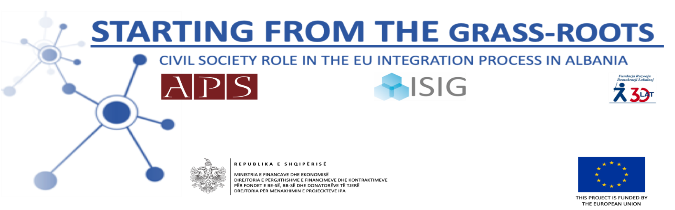

^{Terms of Reference}
Develop an online promotional campaign of E-publication of best practices of cooperation between LAs and CSOs in Albania, Poland and Italy
The Academy of Political Studies (APS) is a non-for-profit organization, established in October 2009, with the purpose to foster a modern political culture based on the shared values of pluralism, tolerance and open dialogue, thus encouraging the emergence of a community of young political and civic leaders, dedicated to implement a contemporary democratic model of government.

The APS organisation is implementing the project “Starting from the grass-roots: Civil society Role in the EU Integration Process in Albania”, under the lot EuropeAid/138384/ID/ACT/AL “Support to Civil Society Organizations for the Implementation of Capacity Building Actions to Increase Policy Dialogue and Awareness on European Integration Process”, funded under the European instrument IPA II European Union Integration Facility 2014. The project is implemented in partnership with Fundacja Rozwoju Demokracji Lokalnej (Foundation in Support of Local Democracy) and ISIG –Institute of International Sociology of Gorizia. Contract number: IPA 2014/AL/15.
The Academy of Political Studies through this project aims at stimulating a structured dialogue between Albanian CSOs and Albanian LAs in order to contribute to the EU integration process. This objective is to be achieved by identification of common interests, potential partnerships as well as barriers and obstacles for further civil society engagement, in particular on the local level of government. The project aims to intervene in the regions of Shkodra, Lezha, Durres, Vlora, Fier.

Purpose

The project aims to create the ground and conditions to set up and improve effective relations between Local Government (LA), community, universities and NGO's to promote the important attempts of policies making and to create an effective cooperation for information of local government on the role of local community, universities, and NGO-s in a democratic society in compliance with EU strategies. To achieve it, the action will start by a thorough analysis of the current situation as regards the institutional and legal framework, resources as well as capacities of local actors to benefit from the EU integration process. The follow up action will aim to increase the understanding and knowledge among LA structures and other local stakeholders on the mutual benefits of adoption and implementation of policies on EU values and better understanding of EU policies, all while enhancing dialogue and cooperation with the Albanian public administration.
The ASP project intervention is aimed at:
- Strengthen Institutional capacity of local government and CSOs
- Increased the understanding of LAs and CSOs in the EU integration

The project activities will be addressed towards CSOs (community-based organisations, NGOs, foundations, research institutions, trade unions, women’s organisations, cooperatives, professional and business association, media, individual citizens) and local authorities representatives who will learn and train together having a unique opportunity to know each sector’s potentials for cooperation as well as obstacles and barriers that need to be overcome for achieving the synergy effect in the future. The training events and public debates to be organised at the universities of Shkodra, Durres and Vlora will be addressed towards students, CSOs representatives, local authorities, civil servants, citizens and media. Project will last for 18 months starting indicatively in October 2018.

Duties and responsibilities

Under the overall supervision of the project manager, the service provider is expected to develop an online promotional campaign of E-publication of best practices of cooperation between local authorities and civic society actors in Albania, Poland and Italy.
The service must include:
- Determine the online platforms for promotion
- Defined targeted audiences and dedicated budgets
- Daily performance monitoring

The maximum amount for the requested service is 800 EUR (Including VAT).

Company profile:

- Preferable Experience working in the related fields.

Application

We expect proposals to be submitted in English or Albanian (English preferred) in closed envelopes, by 1 October 2020, at 16.00 o’clock, at the Academy of Political Studies Office: Rruga “Emin Duraku”, Pallati Credins, Hyrja 1, kati 7, Ap. 21, Tiranë. Proposals will be evaluated according to the following criteria:

Evaluation criteria | Rating
1. On time delivery of the products | 40
2. Experience of the company | 20
3. Costs for products | 40
Total Points | 100

