Public relation online strategies of ISIS in Albania
Working paper - Albania as case study

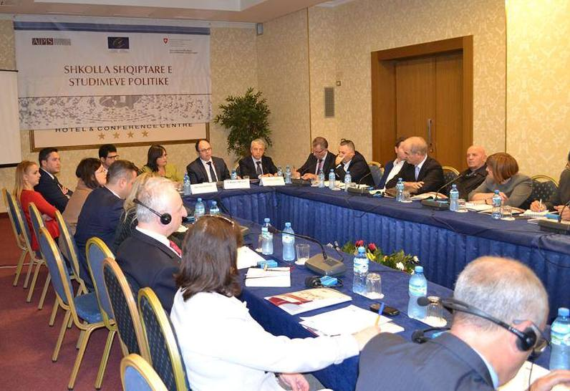

Working Team:
- Fabian Zhilla
- Elena Çibuku
- Irma Kopliku
- Erton Graceni
- Admir Malaj

Concept
One of the ASP objectives is to enable its participants to organize public discussions aimed at fostering constructive public debate on topics important for Albanian society. In this context we find that there is a lack of attention to public opinion about a recent phenomenon such as public relations strategies of ISIS to radicalise and recruit Albanians. With this policy paper we aim to open an informative debate build on a short study on the forms of public communication that ISIS uses to both recruit and radicalise Albanians. Given the considerable communication space and opportunities that online public communication provides for terrorist organisation, we think that this topic deserves a special attention and needs to be addressed and discussed by all public actors. While the Balkan Summit held in Tirana this year, was a positive forum which served as a pool of ideas and expert, as yet there is no clear strategy by Albanian government to tackle this problem.
Structure of discussion:
• Presentation of our analysis
• Analytical Questions for discussion
• Recommendations

Products:
1. Policy paper (including suggestions by participants)
2. Discussion group
3. Articles and media analysis (optional)

Methodology
The policy paper is based on two key sources, press and online content. Initially we reviewed the literature and press to have a lay out of ISIS public relation strategies worldwide. Than we collected around 40 video messages, pictures, and assembled content from a number of so called Islamic sites in face book in Albanian language or translated in Albania. We have applied the content analysis methodology to understand the narrative, target group in Albania and online platform used. Data gathering for this report has been conducted between July-September 2015. We borrow the definition of Mc Farlane on what constitute online violent extremism in disseminating and sorting online content to persuade and radicalise individuals to violent extremism. Mc Farlane (2010) points out that online violent extremism means “the use of online communication systems as a means to facilitate, and/or influence individuals or groups, in developing, adopting, and/or advancing belief systems which lay outside the relative norms of mainstream society resulting in the advocation of threats, and/or physical acts, of violence, to further that belief system”
This analysis will be presented to the participants by raising some questions for discussion. Among the invited experts will be representatives of executive, legislative, prosecution, police, media, academia civil society, religious communities and international community. All suggestions will be recorded and will be attached to the paper which will then be published online on the ASP. We will discuss some video and online messages of ISIS targeting Albania as well as promotional videos Albanians fighting there.
All suggestions will be noted recorded and included in the final policy paper which will be published online on the ASP, and will be presented to institutions and structures responsible for national security such as the Parliamentary Commission on National Security, the Prime Minister, Ministry of Defence, Ministry of Interior, and National Informative Service. The document will also be send to other interest groups which work with the issues of terrorism and radicalisation.
Background
Religious extremism remains a challenge to both developed and developing countries. While with the end of Al Qaeda many thought that armed rebellion of religious extremism will be marginalized, this assumption appears unsupported. The case of the so called Islamic State of Iraq and al-Sham (ISIS) shows in fact that these armed groups have become larger. What is becoming disturbing is that the number of foreign fighters coming from West to join ISIS is very high and probably the highest compared to other similar militant organizations before. According to US intelligence sources, the size of foreign fighters that have joined ISIS takes 50% of its whole army (i.e. 16,000-20,000) out of 31,000 in total. They come from more than 80 countries, including here countries like USA, UK, Germany, France and small countries like Albania and Kosovo. According to the UN, the recruiters come from countries not known for being as “hot spots” of violent extremism before.
In stark contrast with Al Qaida which was a mobile structure without a fixed territory, hierarchical, hidden and with a combatant like modus operandi, the ISIS acts openly, heavily armed, with regular forces, and with a state governance orchestrated attacks. As Richard Nicolazzo notes “twisted groups like ISIS relied on relatively mundane (and now somewhat arcane) means of communications...meetings in villages, rallies, leaflets, newspapers, radio, television, etc.
In stark difference with previous armed groups, ISIS is distinct in the very successful use of online propaganda machine to recruit and convey its message to the public. In a 2014 article New York Time highlights the large scale of online followers of ISIS. The overall twitter account counted two million followers where only 200,000 were coming from the Arab league twitter. As Nicolazzo highlights “Today, the Internet has become an instantaneous global propaganda platform for ISIS to disseminate messages of hate and murder.”
Part of ISIS’s public relation strategy (PR) is the use of violent video messages or loaded pictures with heavy images to radicalise its followers but also to become attractive and appear strong. The powerful global media outlets and international community have tarnished reputation of ISIS. However, the recruitment rate of foreign fighters increased rapidly, around 15,000 in only three months. And this unprecedented answer to a militant group call is mainly due to their public relation efficiency. The quality of this work is said to be of a good standard taking into account the aims and expertise of organisers. In the following part of our work we focus on a short analysis of ISIS online public relations strategy in Albania.

The Scale of phenomenon in Western Balkans
There are around 600 to 700 hundred foreign fighters from the Western Balkans (i.e. Albania, Kosovo, Serbia, Montenegro, Bosnia Herzegovina and Macedonia) who have travelled to Syria and Iraq between 2012 and 2015 (Shtuni 2015a). The majority are ethnic Albanians. Numbering around 500, ethnic Albanians make up about 80 per cent of the total fighters (Shtuni 2015b). While there is still uncertainty about the right figure, according to the available public sources, the number of ethnic Albanians from Albania varies between 90 and 148. In Kosovo this number is doubled. According to a recent interview with Kosovo’s Minister of Internal Affairs for Voice of America, the number was 300 as of 20February 2015.
The number of arrested home-grown individuals, especially in Albania and Kosovo, with links to extremist groups in the Middle East is also high. In March 2014, 13 people were arrested in Albania for allegedly recruiting 70 ethnic Albanians to join Jabhat al-Nusra and later ISIS, and 9 of them are currently being tried in the Serious Crime Court (Spahiu 2015). In Kosovo this number is much higher. Since 2013 there have been 80 people arrested allegedly aiding and supporting ISIS with 5 being arrested as late as 11 June 2015. Kosovo seems the most affected country in the Western Balkans. Compared with other western countries, Kosovo’s recruitment rate (16 fighters/100,000 nationals) is 8 times higher than in France, the largest source of foreign fighters in Syria and Iraq (Shtuni 2015b).

Analysis
While there is a growing research on the online public relation strategies of ISIS worldwide, our study is the first work on ISIS’s online propaganda in Albania. Although there a few studies on the push factors in Albania that prompted some to join ISIS, what remains unclear is the way of public relations strategies ISIS uses to attract Albanians. Unlike previous armed groups, ISIS is distinct in its very successful use of the online propaganda machine to recruit and convey its message to the public. The overall twitter account counted 2 million followers where only 200,000 were coming from the Arab league twitter. ISIS has exploited online recruitment and radicalisation even in the Western Balkans. In a series of video messages Lavderim Muhaxheri (one of the key commanders of ISIS) calls for Albanians to join the cause. As late as June 2015, via a 20-minute video, ISIS threatens “non-believers” in the Western Balkans through the voice of three foreign solders (two ethnic Albanians and one from Bosnia and Herzegovina).
As mentioned earlier international reports and press analysis highlight that compared to other terrorist groups ISIS, the most effective tool of the latter is a well-crafted public relation strategy and high standard online communication tools. Studies identify three messages that underpin the communication strategy. The first being, gathering 'believers' together in one place a sort of caliphate. The second, raising the prestige of “umme” in front of disbelievers (mainly the west) and promotion of a governing model through fierce violence. Unlike the propaganda of other terrorist organizations considered as terrorist ISIS does not seek to justify violence but just show strength through violence. Therefore violence is instrumental in promoting peace and justice. In addition, regarding the last element, it should be mentioned that the results on the ground give ISIS a simple narrative which can be grasped quickly and spread at the target audience which are mostly Muslims, media and law enforcement agencies.
One of the key PR strategies of ISIS is to communicate to public via its own people or voices. Global messages are "official" messages send in two key languages, Arabic and English while targeted messages for targeted countries are send on national languages. Another strategy is the "informal" way of communication where representatives of ISIS communicate not on behalf of ISIS but from their own experiences (i.e. individual messages). The most used tools are social media (i.e. face book, twitter and Instagram). In Albania face book seems the most used social media to communicate. As noted ethnic Albanians are one of the most targeted group to recruit and ISIS has used all forms of communication such as general video messages and specified messages only for Albanians or "Muslims in Western Balkans". ISIS has manifested all above mentioned communication strategies to attract and radicalize Albanians in both Albania and Kosovo.
Suggestions
- Policies toward thwarting recruitment strategies of ISIS in Albania should consider an online counter narrative rather than harsh policies of imprisonment and “online” battle between state (i.e. shooting down extremist websites) and radicalised individuals.

- The state online “war” appears to have failed as the more websites or face book account law enforcement agencies close the more radicalised individuals open. And this makes them more sophisticated.

- Instead of spending resources on online tools, government should consider offline factors that push these individuals to get in contact and communicate with ISIS.

- The focus should be oriented toward social factors and ways of integrating online radicalised individuals to society.

- The issue of ISIS has also shown that recruitment is not only individual but bears community bonds. Many people have joined ISIS in group of friends or families, and this calls for governments’ strategies to be guided to this direction.

________________________
Tirana, 13 November 2015
________________________

This document was prepared in the framework of the public initiatives organised by the participants of the “Albanian School of Political Studies”, thanks to the support of the Academy of Political Studies.

Mc Farlane B (2010) “Online Violent Radicalisation (OVeR): Challenges facing Law Enforcement Agencies and Policy Stakeholders” Global Terrorism Research Centre and Politics, Department Monash University, accessed at: http://artsonline.monash.edu.au/radicalisation/files/2013/03/conference-2010-online-violent-radicalisation-bm.pdf, on 11/10/2015.
http://www.odwyerpr.com/story/public/4155/2015-03-03/confronting-isis-ultimate-pr-challenge.html
http://www.theguardian.com/world/2014/oct/30/foreign-jihadist-iraq-syria-unprecedented-un-isis
http://www.theguardian.com/world/2014/oct/30/foreign-jihadist-iraq-syria-unprecedented-un-isis
http://www.nytimes.com/2014/09/27/world/middleeast/us-vividly-rebuts-isis-propaganda-on-arab-social-media.html?_r=0
http://www.odwyerpr.com/story/public/4155/2015-03-03/confronting-isis-ultimate-pr-challenge.html
https://www.bellingcat.com/news/mena/2015/02/11/how-the-islamic-states-massive-pr-campaign-single-handedly-secured-its-rise/
Interview with Skender Hyseni, Kosovo’s Minister of Internal Affairs (Intervistë me Skender Hysenin, Ministrër i Brendshëm i Kosovës).Voice of America (Albania), 20 February 2015.Available at: https://www.youtube.com/watch?v=gQiPUL9pJTk
Report inquiring into the causes and consequences of Kosovo citizens’ involvement as foreign fighters in Syria and Iraq, Kosovar Center for Security Studies, 14 April 2015, http://www.qkss.org/en/Occasional-Papers/Report-inquiring-into-the-causes-and-consequences-of-Kosovo-citizens-involvement-as-foreign-fighters-in-Syria-and-Iraq-408
The Guardian “Kosovo cuts Pristina water supply over alleged ISIS plot to poison reservoir”, The Guardian, Agency in Kosovo, 11 July 2015. Available at: http://www.theguardian.com/world/2015/jul/11/kosovo-cuts-pristina-water-supply-over-alleged-isis-plot-to-poison-reservoir
Knowlton, B. “Digital war takes shape on websites over ISIS”, New York Times, 26 September 2014. Available at: http://www.nytimes.com/2014/09/27/world/middleeast/us-vividly-rebuts-isis-propaganda-on-arab-social-media.html?_r=0
Meek, G. J. “ISIS aims new recruitment video at Balkan Muslims” ABC News, 5 June 2015. Available at: http://abcnews.go.com/International/isis-aims-recruitment-video-balkan-muslims/story?id=31554167
Plesch, V. “Kosovo to stem flow of ISIL recruits” Aljazeera America, 23 September 2014. Available at: http://america.aljazeera.com/articles/2014/9/23/kosovo-tries-to-stemflowofisilrecruits.html

